NAME : U.SAI VAMSHI

ENROLLMENT NO : 2403A51435

BATCH NO : 17

BRANCH : CSE

Question : 1

Scenario: In the domain of Education, a company is facing a challenge related to algorithms  
with ai assistance.

Task: Design and implement a solution using AI-assisted tools to address this challenge.  
Include code, explanation of AI integration, and test results.  
Deliverables: Source code, explanation, and output screenshots

Prompt :Give me a python code for sorting algorithms in simple terms and generate Python code for Bubble Sort with comments

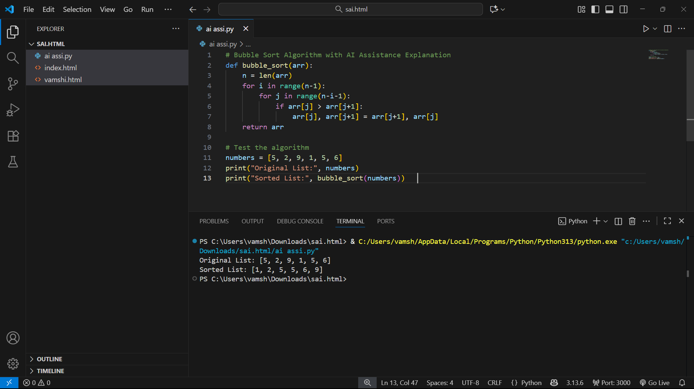

Question : 2

Scenario: In the domain of Smart Cities, a company is facing a challenge related to code  
refactoring.  
Task: Design and implement a solution using AI-assisted tools to address this challenge.  
Include code, explanation of AI integration, and test results.  
Deliverables: Source code, explanation, and output screenshots

Prompt :

Write a simple Python program that shows how AI can help improve smart cities by making code cleaner and easier to understand.

